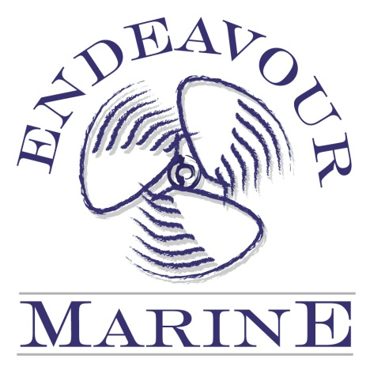

Endeavour Marine Pty Ltd
1 Nanda St.
Marmong Point NSW 2284
ABN 66 103 884 608

Telephone: (02) 4958 4588
Fax Number: (02) 4958 4091
Email: admin@endeavourmarine.com.au

Dear Customer,

The attached is a Work Authority form which we require you to complete, sign and return prior to work commencing on your vessel.

Your credit card details will be held as a deposit on file until the completion of work, when an invoice will be presented and payment required upon receipt of invoice. Should no correspondence or payment via EFT, cheque or cash be received, the invoiced amount will be charged to the credit card (including any fees applicable).

Please return signed authority via email or fax at your earliest convenience.

We would like to take this opportunity in advance, to thank you for your custom.

Regards
Endeavour Marine Pty Ltd

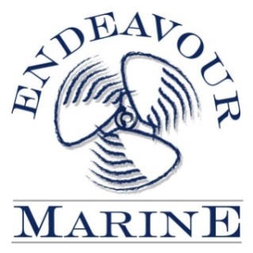
1Nanda Street, Marmong Point NSW 2284
Ph: 02 49584588 Fax: 02 49584091
admin@endeavourmarine.com.au
ABN: 66 103 884 608

CONTRACT TO PROVIDE GOODS AND SERVICES
DATE:
Owner:
Address: Post Code:
Phone No: Fax No: Mobile No:
Email:

DESCRIPTION OF WORK REQUESTED:___________________________________________________________________________________
_____________________________________________________________________________________________________________________
_____________________________________________________________________________________________________________________
_____________________________________________________________________________________________________________________

Trading Terms and Conditions:

* Full payment is due and payable on completion of work and receipt of invoice.
* Unless previously arranged with Management, and should no correspondence or payment via EFT, cheque or cash be made upon receipt of invoice, the invoiced amount will be charged to the credit card (including any fees applicable).
* Goods shall remain the property of the Company until paid for in full.
* The owner will be subject to legal proceedings should payment not be made in accordance with this condition and will be liable for all costs incurred by this debt collection should this course of action occur.
* A Repairer’s Lien will be held over the vessel until payment is made in full.
* Progress payments or pre-payment of parts/materials may be required and is at Endeavour Marine’s discretion.
* Visa, Mastercard & Eftpos surcharge fees will apply to Invoice amounts over $1000 (Fees as per Cost of Acceptance Table)
* Labour rate $120.00 + gst per hour.
* Contract will extend to any works undertaken for a period of 6 months from dated signed below.

Owner / Owner’s Representative Authorisation : ………………………………….……………………………Date: ………………………...…

Authority : The owner/owner’s representative authorises and commissions the provider to supply the Goods and Services subject to the above terms and conditions hereby which the owner/owner’s representative acknowledges having read and accepted. Under no circumstances will the provider be obliged to commence work until such time as this contract is executed by the owner and returned to the provider.

Credit Card Authority is required prior to commencement of work.
CREDIT CARD AUTHORISATION :

Name: _______________________________________________(Visa, Mastercard & Eftpos surcharge As Per Cost of Acceptance Table)

Credit Card No: ______________________________________________________________________ Exp Date: __________________

Signature: ______________________________________________________________________________________________________

